Follow the second procedure that is the correct one

My Linux kernel version= 5.3.0-48 generic

My downloads for Xenomai installations: (The same files and versions which we used for )
Xenomai version downloaded= xenomai-2.6.1
Linux kernel version= linux-3.2.21
Adeos Ipipe= ipipe core 3.2.21 -x86-5.patch

This is how you unzip in linux terminal
tar xvjf linux-x.y.z.tar.bz2
tar xvzf linux-x.y.z.tar.gz

First Procedure:
- Go inside the home director unzip the file xenomai and linux.
- Go inside xenomai cd xenomai-2.6.1/ and type this command next scripts/prepare-kernel.sh --arch=x86_64 --adeos=../ipipe-core-3.2.21-x86-5.patch --linux=../linux-3.2.21 patch will add.
- After that do cd .. and go inside linux-3.2.21 then type this cp /boot/config-5.3.0-46-generic .config
- Then do make menuconfig feature it in the below way

* General setup
--> Local version - append to kernel release: -xenomai-2.6.5
--> Timers subsystem
--> High Resolution Timer Support (Enable)
* Real-time sub-system
--> Xenomai (Enable)
--> Nucleus (Enable)
--> Pervasive real-time support in user-space (Enable)
* Power management and ACPI options
--> Run-time PM core functionality (Disable)
--> ACPI (Advanced Configuration and Power Interface) Support
--> Processor (Disable)
--> CPU Frequency scaling
--> CPU Frequency scaling (Disable)
--> CPU idle
--> CPU idle PM support (Disable)
* Pocessor type and features
--> Processor family
--> Core 2/newer Xeon (if \"cat /proc/cpuinfo | grep family\" returns 6, set as Generic otherwise)
* Power management and ACPI options
--> Memory power savings
--> Intel chipset idle memory power saving driver (Disable)
- Save changes then type make, if you encounter error something like "cc1: error: code model kernel does not support PIC mode."
I typed this,
~/linux-imx6$ export ARCH=arm
~/linux-imx6$ export CROSS_COMPILE=arm-linux-gnueabi-
then I gave make then this error came
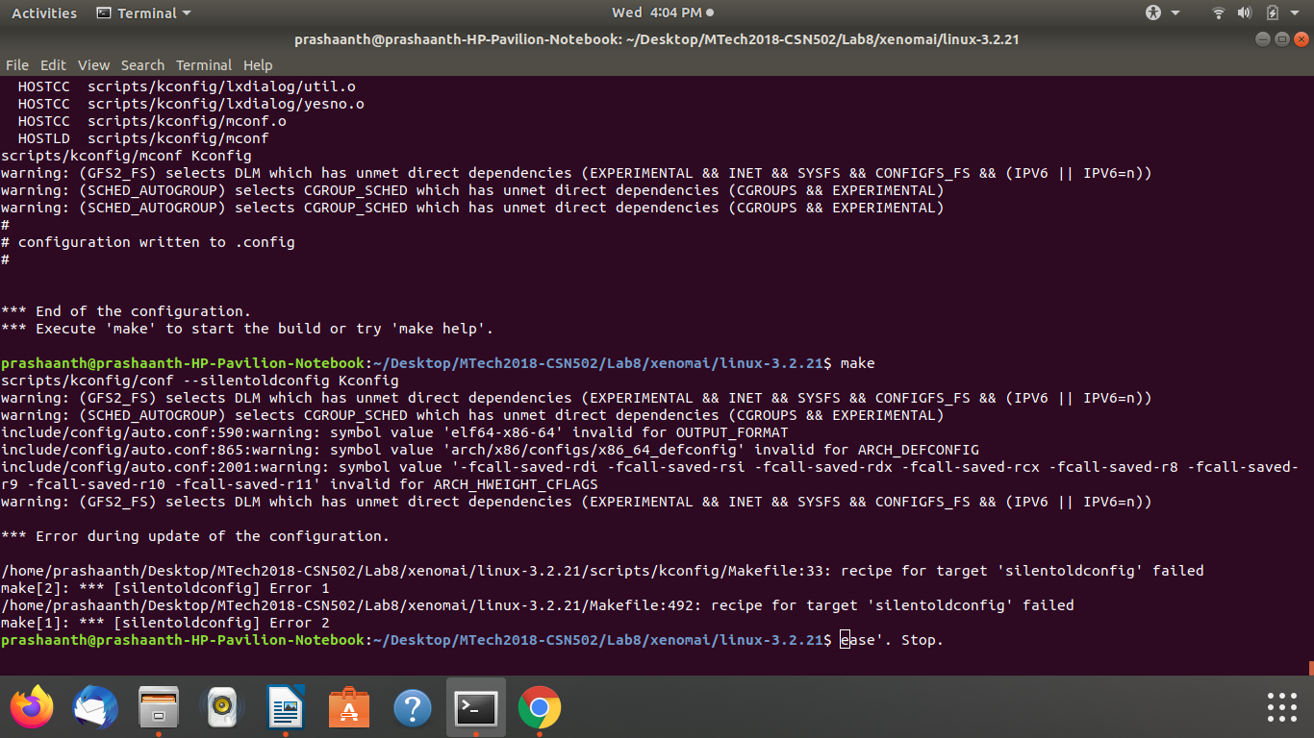
Second procedure:

My Linux kernel version= 5.3.0-48 generic

My downloads for Xenomai installations: (The same files and versions which we used for )
Xenomai version downloaded= xenomai-3.0.7
Linux kernel version= linux-4.9.90
Adeos Ipipe= ipipe core 4.9.90 -x86-6.patch

- Go inside the home director unzip the file xenomai and linux and use wget and install the corresponfing adeos ipipe cersion in the folder.
- Go inside xenomai cd xenomai-3.0.7/ and type this command next scripts/prepare-kernel.sh --arch=x86_64 -–adeos=../ipipe-core-4.9.90-x86-6.patch –-linux=../linux-4.9.90 patch will add.
- After that do cd .. and go inside linux-4.9.90 then type this cp /boot/config-5.3.0-46-generic .config (before doing this step check your kernel number uname -r).
- Do this sudo apt install libncurses5-dev.
- Then do make menu config
Recommended options:

* General setup
--> Local version - append to kernel release: -xenomai-3.0.5
--> Timers subsystem
--> High Resolution Timer Support (Enable)
* Xenomai/cobalt
--> Sizes and static limits
--> Number of registry slots (512 --> 4096)
--> Size of system heap (Kb) (512 --> 4096)
--> Size of private heap (Kb) (64 --> 256)
--> Size of shared heap (Kb) (64 --> 256)
--> Maximum number of POSIX timers per process (128 --> 512)
--> Drivers
--> RTnet
--> RTnet, TCP/IP socket interface (Enable)
--> Drivers
--> New intel(R) PRO/1000 PCIe (Enable)
--> Realtek 8169 (Enable)
--> Loopback (Enable)
--> Add-Ons
--> Real-Time Capturing Support (Enable)
* Power management and ACPI options
--> CPU Frequency scaling
--> CPU Frequency scaling (Disable)
--> ACPI (Advanced Configuration and Power Interface) Support
--> Processor (Disable)
--> CPU Idle
--> CPU idle PM support (Disable)
* Pocessor type and features
--> Enable maximum number of SMP processors and NUMA nodes (Disable)
// Ref : http://xenomai.org/pipermail/xenomai/2017-September/037718.html
--> Processor family
--> Core 2/newer Xeon (if "cat /proc/cpuinfo | grep family" returns 6, set as Generic otherwise)
// Xenomai will issue a warning about CONFIG_MIGRATION, disable those in this order
--> Transparent Hugepage Support (Disable)
--> Allow for memory compaction (Disable)
--> Contiguous Memory Allocation (Disable)
--> Allow for memory compaction
--> Page Migration (Disable)
* Device Drivers
--> Staging drivers
--> Unisys SPAR driver support
--> Unisys visorbus driver (Disable)
- Next type this sudo apt install kernel-package
CONCURRENCY_LEVEL=$(nproc) make-kpkg --rootcmd fakeroot --initrd kernel_image kernel_headers
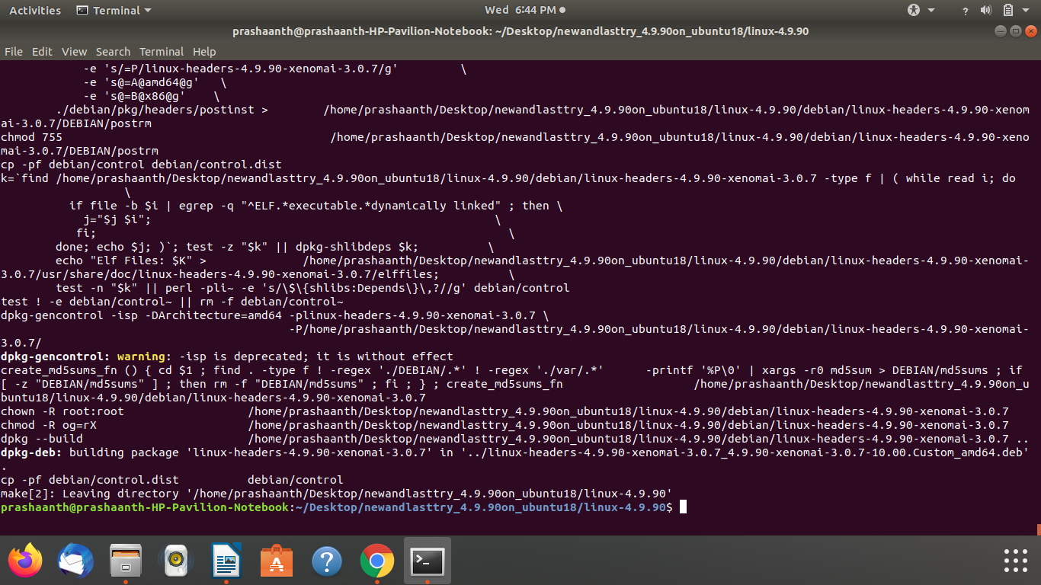
- After that do
cd ..
sudo dpkg -i linux-headers-4.9.38-xenomai-3.0.5_4.9.38-xenomai-3.0.5-10.00.Custom_amd64.deb linux-image-4.9.38-xenomai-3.0.5_4.9.38-xenomai-3.0.5-10.00.Custom_amd64.deb

- Run these 3 commands
sudo addgroup xenomai --gid 1234
sudo addgroup root xenomai
sudo usermod -a -G xenomai $USER

- Update the grub sudo nano /etc/default/grub
GRUB_DEFAULT="Advanced options for Ubuntu>Ubuntu, with Linux 4.9.38-xenomai-3.0.5"
#GRUB_DEFAULT=saved
#GRUB_SAVEDEFAULT=true
# Comment the following lines
#GRUB_HIDDEN_TIMEOUT=0
#GRUB_HIDDEN_TIMEOUT_QUIET=true
GRUB_TIMEOUT=5
GRUB_CMDLINE_LINUX_DEFAULT="quiet splash xenomai.allowed_group=1234"
GRUB_CMDLINE_LINUX=""
- Then do this sudo update-grub
- Then sudo reboot
- After reboot follow the steps that are present in the first reference link

Reference link from which I did the installations:

- https://rtt-lwr.readthedocs.io/en/latest/rtpc/xenomai3.html = that xenomai 2.3.6 to ubuntu 16.04 and 14.04 that one.
- https://elinux.org/images/1/13/3DPrintingXenomai.pdf = this ppt shows the compatiability.
- https://www.youtube.com/watch?v=8gYYXiir8W8 = main video for xenomai installation.
- https://www.xenomai.org/pipermail/xenomai/2018-October/039684.html = Last and final hope this is the correct link

